**Section 1: Metadata**

*to be filled by the student*

**1.1. Project Information** to be filled by the student

|  |  |
| --- | --- |
| Title: DairyPro | |
| Section: L3 | Instructor: Dr. Faisal Alvi |

**1.2. Student(s) Information**

|  |  |
| --- | --- |
| Name: Elyan Ali Momin | ID: em08434 |
| Section: L3 | Batch: CS 2026 |

|  |  |
| --- | --- |
| Name: Sarah Faisal Sikandar | ID: sf08449 |
| Section: L3 | Batch: CS 2026 |

|  |  |
| --- | --- |
| Name: Sameer Kamani | ID: sk08109 |
| Section: L3 | Batch: CS 2026 |

**Submission guideline:** Save your project proposal as a pdf file and rename as Project Proposal_L1_ProposedTitle where L1 is to be replaced with your section

**Section 2: The Project**

*to be filled by the student*

**2.1. Project Description:** *Please provide a brief introduction of the project including its scope.*

Project Description:

DairyPro is a comprehensive Dairy Business Management System designed to streamline and optimize the operations of dairy businesses, from small farms to large-scale dairy processors. The system encompasses a wide range of functionalities, including product management, employee tracking, distributor and marketing channel management, manufacturing process oversight, raw material management, inventory control, and compliance monitoring.

By implementing DairyPro, dairy businesses can efficiently manage their day-to-day operations, ensure product quality, and make data-driven decisions to improve their competitiveness and growth in the dairy industry.

**Scope:** Medium to Large, the scope of the DairyPro project includes the development and implementation of a robust database management system tailored to the unique needs of dairy businesses. This system will encompass various aspects of dairy operations and provide tools and functionalities to manage each of them effectively.

**2.2 Functional Requirements**

*This section describes each function/feature provided by your system. These functions are logically grouped into modules based on their purposes. The users in your system must be categorized such as client, customer or administrator etc. These users will be accessing the database with the level of access that they are authorized with.*

**Module 1:** **Registrations and Log in:**

* Function 1: Register a new user: Customers, distributors, and suppliers can register themselves by supplying necessary details such as name, email, and user type in the registration form which will be connected to the respected tables, adding their information to the table as they submit their details.
* Function 2: Log in: Users will first take to the stakeholder dashboard, where they will select their role and then log in as their designated role.

**Stakeholder 1: Administration:**

**Module 2: Look over all Transactions:**

* Function 3: Admins will have control over all transactions and can view, add, and delete everything through their dashboard. (All Function mentioned for each stakeholder can be managed or modified by the Admin.)

**Module 3: User Access Control**

* Function 4: Assign roles and permissions: Administrators can assign specific roles and permissions to users, granting them access to various parts of the system.
* Function 5: Deactivate user accounts: Administrators can deactivate or suspend user accounts if necessary or requested by the customer, distributor, or the supplier.

**Stakeholder 2: Distributor:**

**Module 4: Distributor Order Management**

* Function 6: View Products: Distributors can search for dairy products based on criteria like product type, brand, or price through the view form that pops up when view button is clicked in the distributor dashboard.
* Function 7: Place an order: Distributors can place orders for dairy products, specifying product quantities, names, and delivery details by clicking the place an order button. The system will prompt them to fill in a form and the order will be generated.
* Function 8: Cancel an Order: Distributors can remove an order if the status does not show “process started” or “processing” in the activity status.
* Function 9: Track order status: Distributors can track the status of their orders, including order processing and delivery updates by clicking the track order button and supplying the order id.

**Stakeholder 3: Customer:**

**Module 5: Customer Order Management**

* Function 10: View Products: Customers can search for dairy products based on criteria like product type, brand, or price through the view form that pops up when view button is clicked in the distributor dashboard.
* Function 11: Place an order: Customers can place orders for dairy products, specifying product quantities, names, and delivery details by clicking the place an order button. The system will prompt them to fill in a form and the order will be generated.
* Function 12: Cancel an Order: Customers can cancel an order if the delivery status does not show “delivery started”.
* Function 13: Track order status: Customers can track the status of their orders, including order processing and delivery updates by clicking the track order button and supplying the order id.

**Stakeholder 4: Supplier:**

**Module 6: Material Supply**

* Function 14: Dispatch form for raw materials: There will be a materials dispatch form where the supplier will notify the admin that their raw materials are dispatched, and that will reflect in the inventory once the raw materials are dispatched.
* Function 15: Track supply status: Suppliers can track and view the status of their supply orders, including order acceptance and delivery updates.

**Stakeholder 5: Employee:**

**Module 7: Employee Management**

* Function 16: View personal information: Employees can view their personal information and employment details by clicking the view info button in their dashboard.

**Module 8: Quality Control**

* Function 17: Record and Update quality assessments: Employees involved in quality control can record assessments and inspections of products updating the Quality Control Table and its attributes. This can be accessed by only those employees whose department is Quality Control.

**Module 9: Manufacturing**

* Function 18: Manage and Update production: Employees responsible for manufacturing can input data about the production process, the expiry of the product, and production efficiency. This can be accessed by only those employees whose department is Production.

**Module 10: Inventory Management**

* Function 19: Update inventory: Employees can update inventory levels, including adding new products and adjusting stock quantities. This can be accessed by only those employees whose department is Inventory.

**Module 11: Compliance and Reporting**

* Function 20: View and Update compliance records: Employees can access, view and update compliance records and documentation. This can be accessed by only those employees whose department is Compliance.

**Module 12: Review and Feedback (Additional Feature)**

* Function 21: Leave product reviews: Customers, distributors, and suppliers can leave reviews and feedback for dairy products they have bought through their respective dashboards when their order status is changed to delivered.

**2.3. Planned Schedule:** *Kindly list the start/end dates and the timeline for the achievement of any intermediate milestones and the expected contribution to be made by the participant(s).*

|  |  |
| --- | --- |
| Week 6 | Populating tables with dummy data |
| Week 7 - Week 10 | Connecting forms from back end using python. |
| Week 11 - 12 | Implementing SQL |
| Week 13 | Working additional functions of the database |
| Week 14 - 15 | Finalizing our project |

**2.4. Technology Stack:** *If you are utilizing any language or database besides PyQt and SQL Server, please complete this section; otherwise, leave it blank. Specify the programming language and database management system intended for constructing this application, as well as the application type (Desktop, Web, or Mobile).*

SOFTWARES:  
1. DBdesigner  
2. MySQL   
4. Visual Studio Code  
5. GitHub

PROGRAMMING LANGUAGES:  
1. Python (pyQt6)  
2. SQL

**2.5. Screens:** *Provide images of all application screens, showcasing clear input and corresponding outputs. Ensure each image includes a concise caption explaining user action and expected/observed output. You can create these screens using Qt Designer.*

**1) User will be greeted with a Login Screen:**

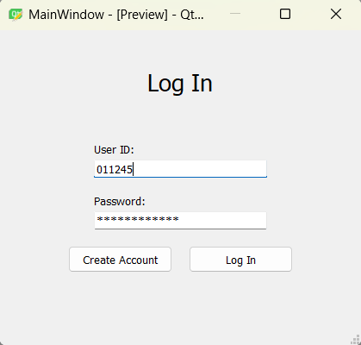

**2) If the User does not have an account they can Sign Up as well:**

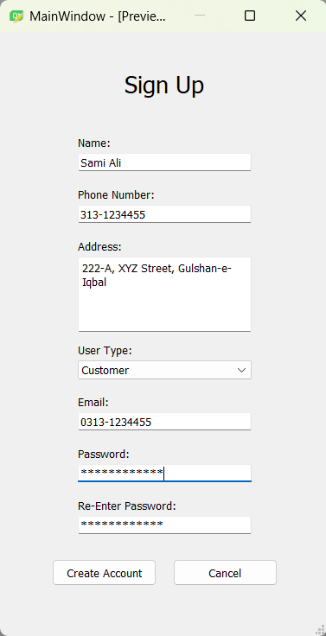

**3) Users can select how they want to Log in (This is only permitted when the user has multiple roles):**

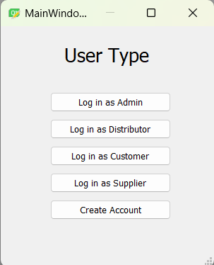

**4) If Logged in as Admin:(Admin Dashboard):**

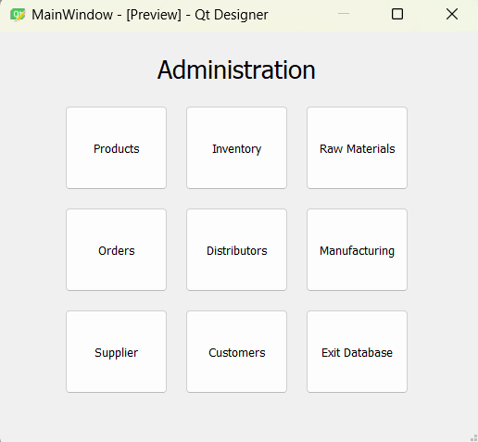

**4a)** Product Button in the Admin Dashboard, gives access to view, search, add, and delete the products:  
  
**4a i)** If View button is clicked in products form:  
  
**4a ii)** If Add button is clicked in products form:

**4b)** If Inventory Button is clicked in the Admin Dashboard:

**4b i)** View Button in Inventory form to view a specific inventory:  
  
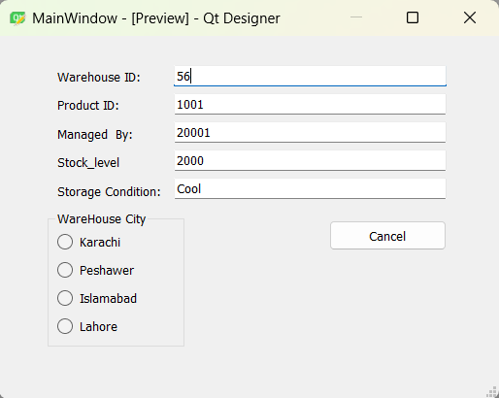

**4b ii)** Add Button in the Inventory form to add a specific inventory:

**4c)** If the Raw Material button is clicked in the Admin Dashboard:

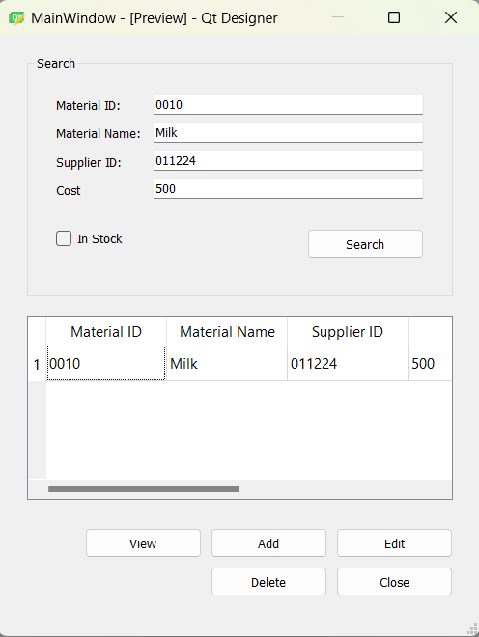

**4c i)** If View Button is clicked in the Raw Material Form:

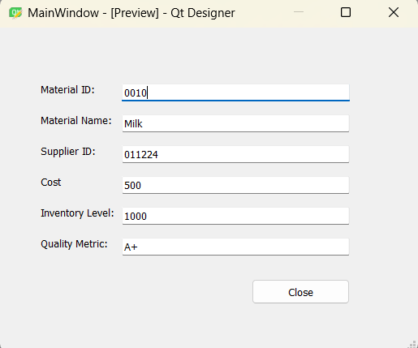

**4c ii)** If Add Button is clicked in the Raw Material Form:

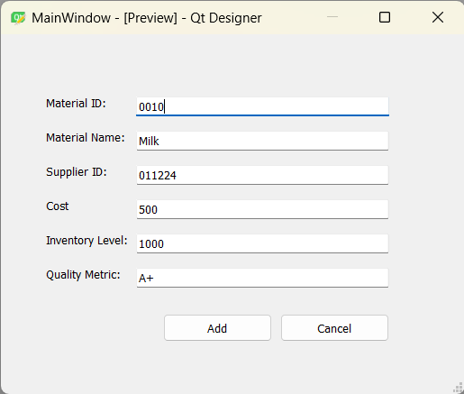

**4d)** If Order Button is clicked in the Admin Dashboard:

**4d i)** If View is clicked in the Order Form:

**4d ii)** If Add is clicked in the Order Form:

**4e)** If Distributors Button is clicked in the Admin Dashboard:

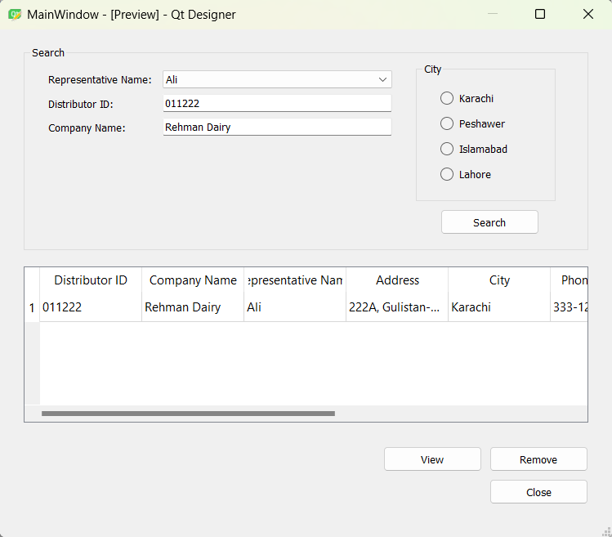

**4e i)** If View Button is clicked in the Distributors Form:

**4f)** If Manufacturing Button is clicked in the Admin Dashboard:

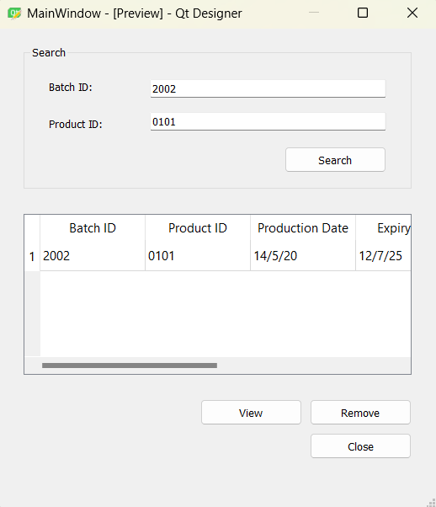

**4f i)** If View is clicked in the Manufacturing Form:

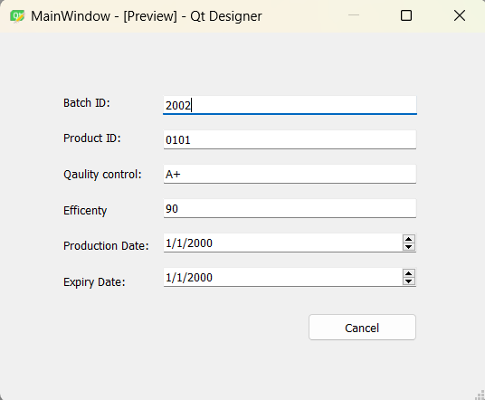

**4g)** If Suppliers Button is clicked in the Admin Dashboard:

**4g i)** If View is clicked in the Supplier Form:

**4h)** If Customers Button is clicked in the Admin Dashboard:

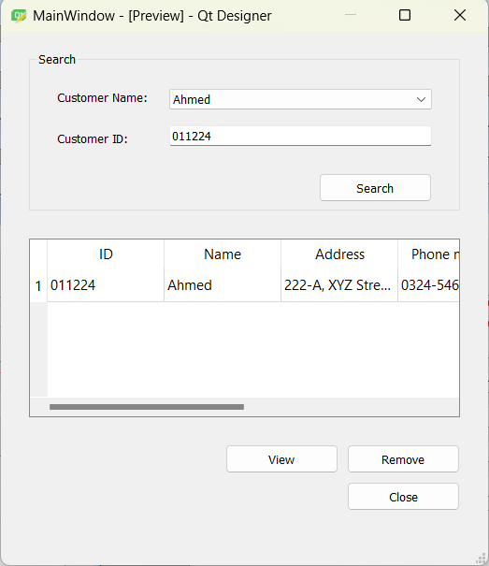

**4h i)** If View is clicked in the Customers Form:

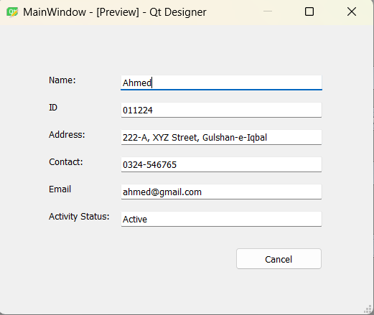

**5) Customer’s Dashboard:**

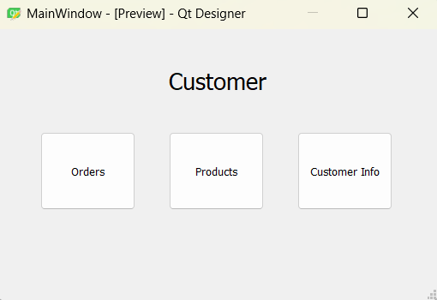

**5a)** If Orders Button is clicked:

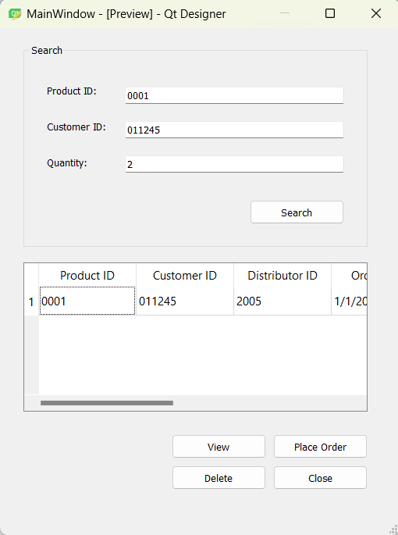

**5a i)** If View Button is clicked in the products Form:

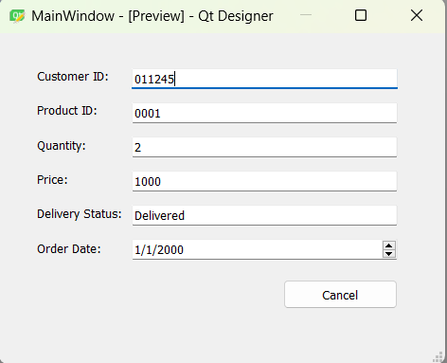

**5a ii)** Customer can Place an order too in the Orders Form:

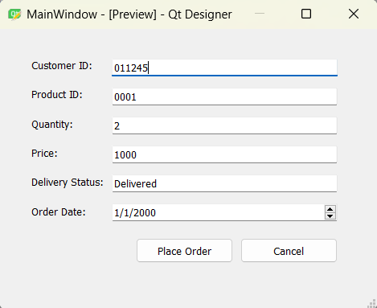

**5b)** Product Button in Customer Dashboard:  
  
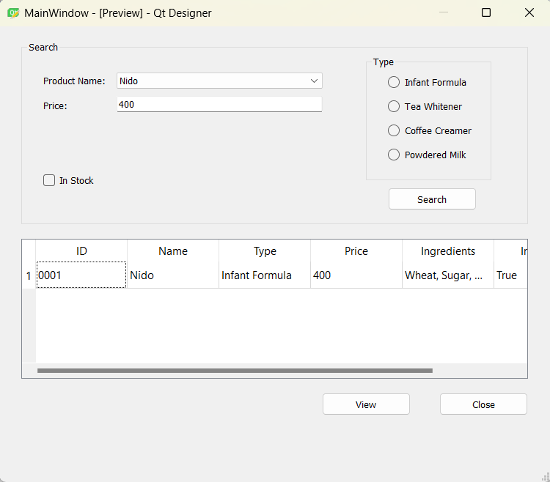

**5b i)** View button in Products Form:

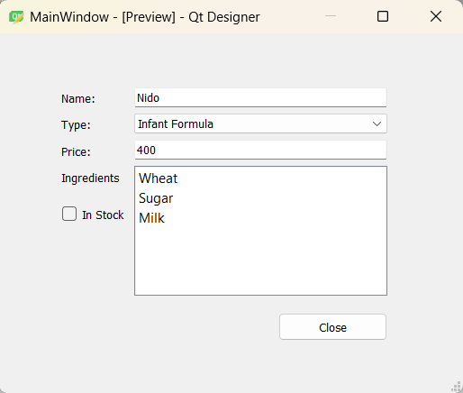

**5c)** Customer information button in Admin Dashboard:

**6) Distributor Dashboard:**

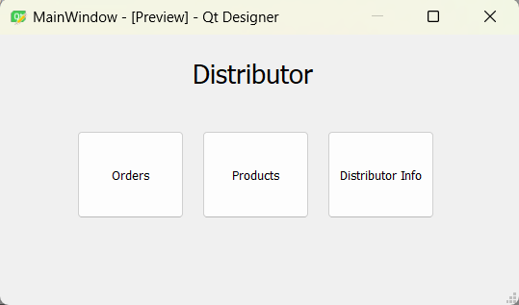

**6a)** Order Button in Distributor Dashboard:

**6a i)** View Button in Order Form:

**6a ii)** Place an order functionality in the Distributor Dashboard:

**6b)** Product Button in Distributor Dashboard:

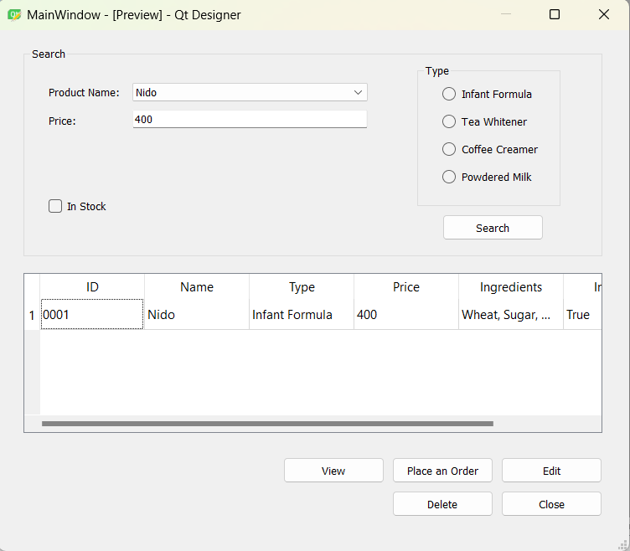

**6b i)** View button in Products Form:

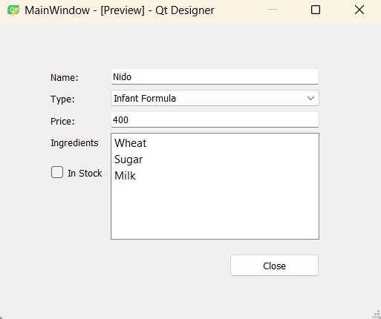

**6c)** Distributors Information button:  
  
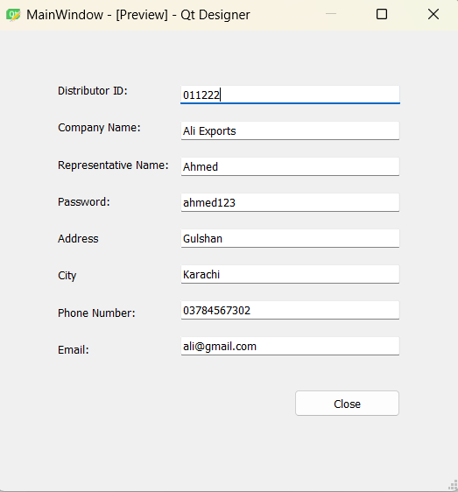

**7) Supplier Dashboard:**

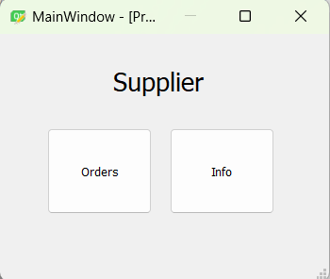

**7a)** Order Button in Supplier Dashboard:

**7a i)** View Button in Orders Form:

**7a ii)** Generate Order (Specific for Supplier) in the Orders Form:

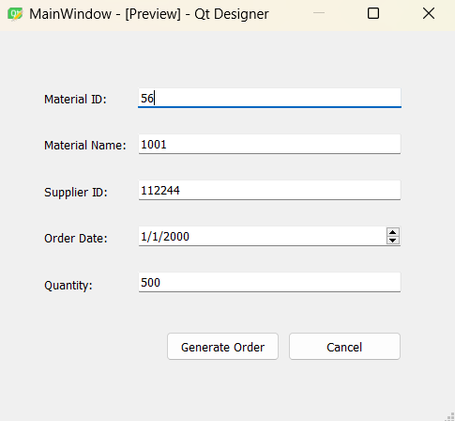

**7b)** Supplier Information in the Supplier Dashboard:

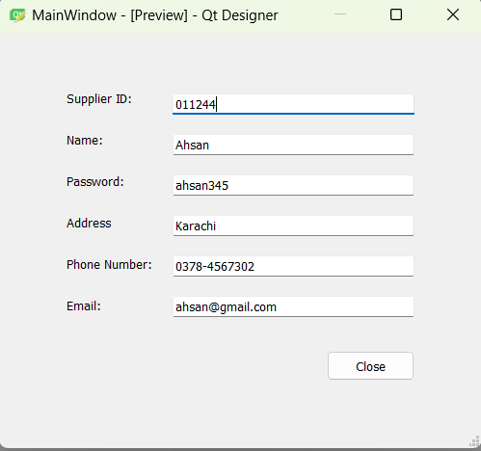

**2.5. ERD:** *Please incorporate an initial ERD for your project, ensuring clear highlighting of primary keys and accurate depiction of table relationships. Avoid manual ERD creation; utilize tools like DBdesigner for this purpose.*

